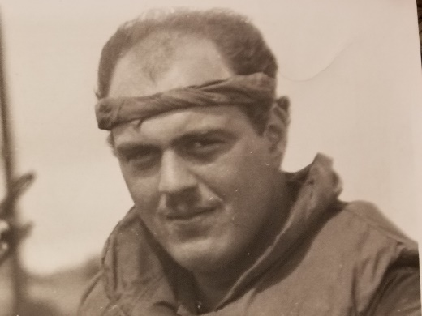

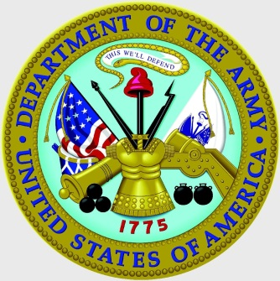

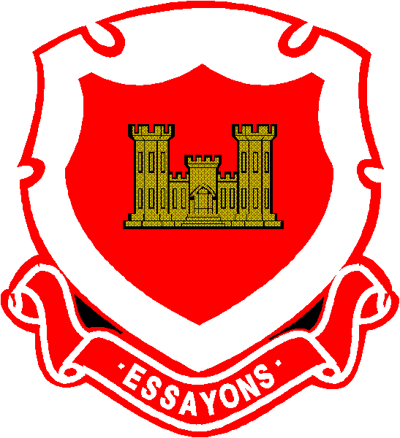

**Sergeant Arthur Segaloff**

**U.S. Army, Vietnam**

Arthur Segaloff was born in Boston, Massachusetts. His was abandoned by his birth mother, and left at an orphanage in Scollay Square in Boston’s West End. He was cared for at the orphanage until age four, when he was adopted by Frances and Peter Segaloff from Brighton, where Arthur grew up. Arthur’s father, Peter, grew up in Boston, and his mother, Frances, was from Queens, New York. Both of their parents, Arthur’s grandparents, had immigrated from the Ukraine at the turn of the 20th century. An interesting fact is that both of Arthur’s grandfathers served in the Russian cavalry. Arthur’s father served as an officer in WWII in the U.S. Army. Arthur’s father had a successful career as a fourth-generation jeweler in their family business on Washington Street in Boston. One of Arthur’s ancestors was actually an apprentice to Faberge in Russia.

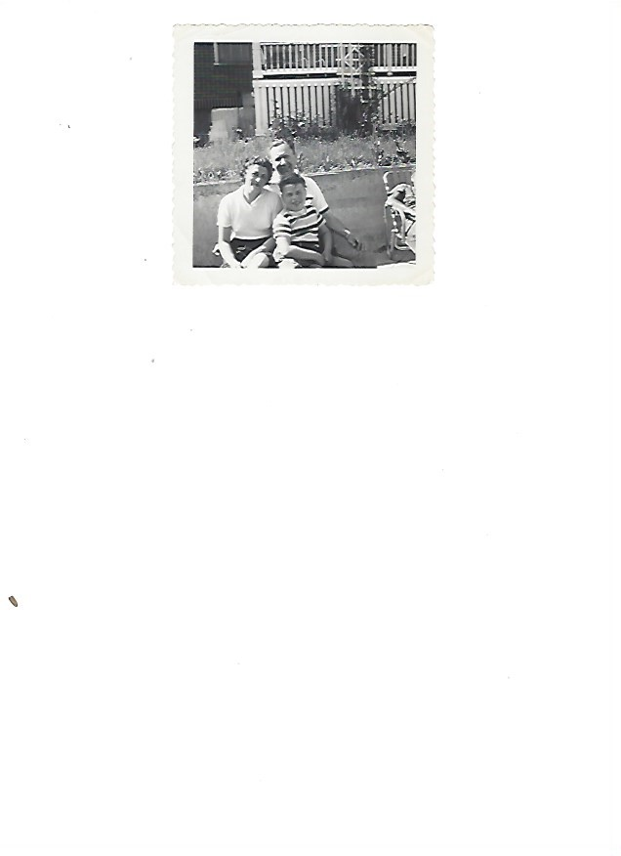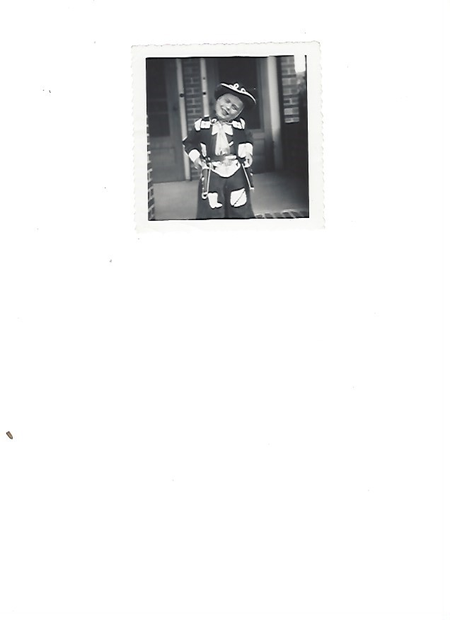

Arthur graduated from Boston Latin High School in 1965, the last class in this high school to have required military training. He graduated from the University of Massachusetts, Amherst, with a major in archeology. Upon graduation in 1969, he was immediately drafted into the U.S. Army. The draft lottery had not yet been initiated. He first went to Fort Dix, New Jersey, for basic training. From there, he went to Fort Leonard Wood, Missouri, where he earned his MOS as a combat engineer. His first assignment, for a short time, was at Fort Benning, Georgia.

In the spring of 1970, Arthur was sent to Vietnam, where he served in the 65th Combat Engineer Battalion of the 25th Infantry Division. In performing his combat engineer missions, Arthur was responsible for demolitions and mine sweeps. His unit was sent to Cambodia, under the direction of President Nixon, a significant, historical marker during the Vietnam War. When the 65th rotated back to its home base in Hawaii, Arthur had not yet completed his 180-day tour in country. He was transferred to the 326th Combat Engineer Battalion of the 101st Airborne Division, where he completed his first tour, and then his second tour. While serving with the 326th, Arthur was given a field promotion to Sergeant (E-5) for valor in action against the NVA.

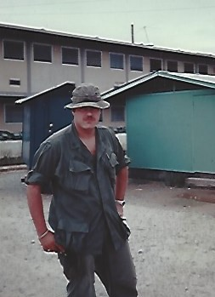

During Vietnam, the 101st Airborne Division was Air Mobile, and Arthur completed over 50 combat air assaults. He received the Air Medal twice. He also received one Bronze Star for Valor, one Bronze Star for Meritorious Service, two Purple Hearts, four Army Commendation Medals for Valor, and the Vietnam Cross for Gallantry with Palm.

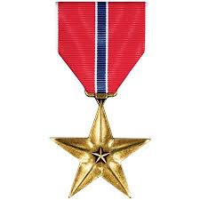

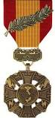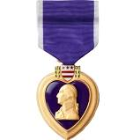

Arthur returned home in January of 1972, and was discharged to start graduate school immediately. He received a master’s degree in education from Boston State College, and later a Certificate in Advanced Graduate Studies.

Even though Arthur had completed his graduate program in education, he went into business and ran a successful printing company in Peabody, Massachusetts for over 20 years. He sold his business, and then had the opportunity to work for FedEx as a general manager for three stores. He held this position for 10 years, and then retired. Since then, he returned to his original vocation and became a Mayan archeologist in Central America for the University of Texas for the next 15 years. He has now finally retired, and is heavily involved in veterans’ organizations.



Arthur met his wife Rona (Litcofsky) Segaloff in 1966 at the University of Massachusetts. They married in 1977. Rona has retired after a career as a social worker in the Department of Public Welfare of the Commonwealth of Massachusetts. They live in Swampscott and have two sons and four grandchildren. His older son, Joshua, is a middle school science teacher, and his younger son, Jamie, is on active duty as a U.S. Army Captain in the 10th Mountain Division at Fort Drum.

Arthur Segaloff is being presented by his long-time friend David Zeller.