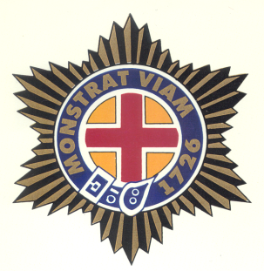

Korean War
Veteran
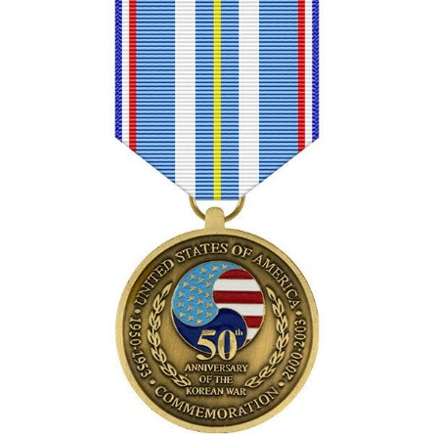

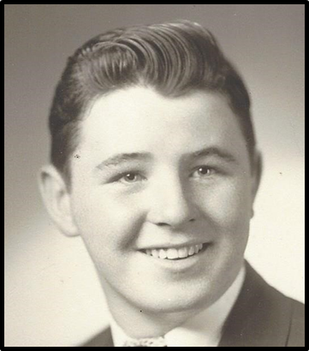
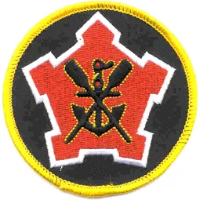

MSG Robert P. Shaw
U.S. Army, Korea

Robert Shaw was born in Boston. His father, Francis, was from Boston. Francis worked in the Fore River Shipyard in Quincy during WWII, and then had a career with the Boston Housing Authority. His mother, Gertrude Cloonan, went to work at the Watertown Arsenal during WWII and raised five children.

Robert grew up in Dorchester and graduated from Hyde Park High School in 1949. He enlisted in the Army right away. Though only 17, Robert had hopes of gaining some skills from the Engineer Corps. He did his basic training at Fort Dix, NJ, and then went by train to Fort Lewis, WA, where he served in an Engineer unit, receiving additional training. There, he also received Admin training and worked as an HQ clerk. Then, the Korean War broke out.

Robert was with the 2nd Engineer Battalion at the Manchurian border. As combat engineers, they built bridges and roads, put in mine fields, and often were actively engaged as Infantry. In November of 1950, they fought against the Chinese in the Battle of Kunu-ri. They were greatly outnumbered, and many of his battalion were captured, wounded or killed. When the Battalion Commander was captured, the colors were burned. The battalion went from 1000 to 237 in three days. Robert was fortunate to survive this brutal attack, even though his unit served as the delaying action for the entire Division. Robert had frozen feet because the temperature was 40 below zero!

Robert was in Korea for 13 months, and he finally returned home in 1951. He was assigned to Fort Campbell, KY, with a combat engineer unit, until 1952, when he was discharged. He returned to Boston and lived with his parents. He was 20 years old. He worked for a short time at the Fore River Shipyard in Quincy, and then reenlisted in the Army. Before he reenlisted, he was smart enough to marry the “girl next door,” Virginia Doherty. He was then stationed in Germany, and Virginia joined him there. They had two children while he was stationed in Germany for three years. He was next stationed at Fort Belvoir, and then became a recruiter in Oklahoma for the next three years. After another two years, at Fort Hood, he returned home to Boston for a recruiting position for the next seven years. Robert and Virginia were able to buy a home in Mansfield, MA, where they raised their six children. In February of 1968, he returned for one year to South Korea. In February of 1969, he then returned to Boston and recruiting, where he remained until his retirement in 1972.

As a civilian, age 39, Robert opened his own business in auto leasing in Braintree, MA. His son and grandson now run this successful business. The Shaw family includes six children, 15 grandchildren, and 10 great grandchildren. The Shaw’s Christmas celebration must be held at a function hall for the 100 family members and their friends who attend!

