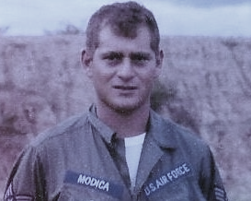
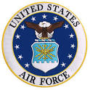
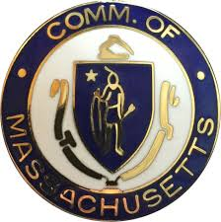

Sergeant Anthony Modica
U.S. Air Force, Vietnam

Anthony Modica was born in Portland, Maine. Anthony’s father, Nunzio was born in East Boston and worked as a longshoreman and also owned a restaurant in Maverick Square, East Boston. His mother, Antoinette, was from Portland. Anthony spent much time in Portland as a child with the extended family. He was raised in East Boston with his mother, father, and sister Diane.

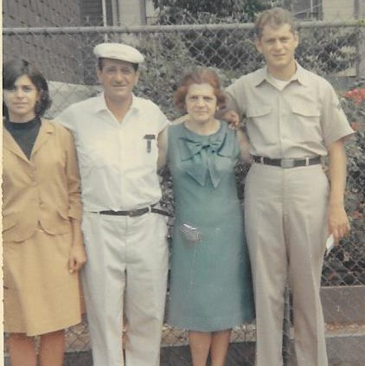
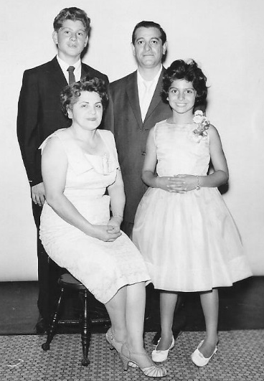

Anthony graduated from Boston Trade High School in 1961 and then attended the Boston University Aviation Technology program at Logan Airport for a year. He then went to work at Boston Insurance for a few years.

In early 1964, he received his draft notice. He joined the Air Force. In June of 1964, Anthony was sent to Lackland AFB in San Antonio, Texas for basic training. He then was sent to Amarillo AFB, also in Texas, for Jet Aircraft Mechanic Training. In the fall of 1964, he got his orders for Dover AFB in Delaware, where he remained, serving in the 95th Fighter Interceptor Squad until the spring of 1966. His job was as Crew Chief, in charge of maintaining aircraft, pre- flight and post-flight. Then he was sent to Atlantic City, New Jersey. In June of 1966, Anthony received orders to go England AFB in Louisiana. He was lucky that he had cousins who lived in Baton Rouge whom he visited frequently during his weekend times off.

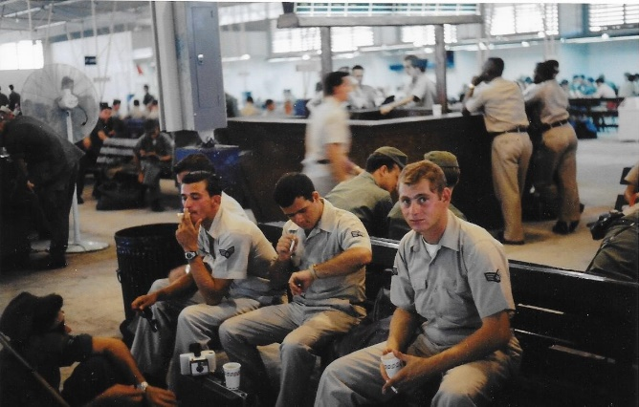

In September of 1966, he was finally deployed. Anthony left Louisiana for a 20-hour flight, with many stops, finally arriving in country in the 614th Squad at Phan Rang Air Base. With an abundance of manpower, they gave Anthony a choice of other assignments. He selected Transit Alert, maintaining aircraft from other bases, which he did for the 12 months that he served in Vietnam. He still remembers the snakes, the cold at night, and the darkness.
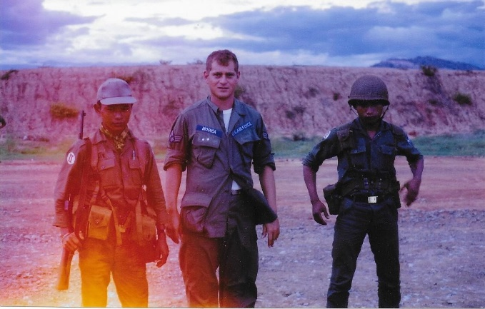
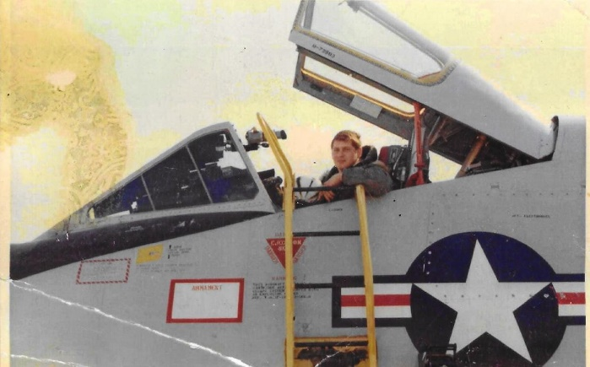

Anthony returned to the United States in September of 1967. He was ordered to Dover, Delaware again, but instead went to Atlantic City to get his orders changed so that he could be stationed there for his last 7 months. This was accomplished, and he worked at the FAA National Experimental Center, where he serviced two planes, pre-flight and post-flight, sent there from Dover each day. On May 28, 1968, he was discharged. For his service, he received numerous medals, including the Vietnam Campaign Medal, the Vietnam Service Medal, the National Defense Medal, the Air Force Commendation Medal, and several Unit citations.

He took the summer off, and when the fall came, he began longshoring, while also working in maintenance at Northeast Airlines. A couple of years later, he went to work in the elevator business, which became be his long-term career. He worked in elevator construction and repair for 32 years, retiring in 2003. He then became a state elevator inspector, a position he still holds today.

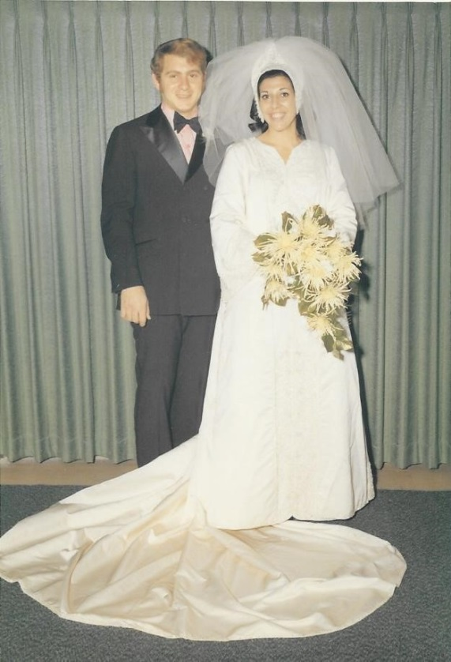
Anthony met his wife Angela (Mantone) at Revere Beach in 1962. After he completed his military service, they started dating. They married in 1969. Angela worked for the New England Telephone company for 11 years. Their son Jeff, born in 1973, holds a degree in finance from the University of Massachusetts and works for BlackBox, providing telecommunications management services for the US DOT and the US Veterans Services. Their son Chris was born in 1975 and holds a master’s degree in civil engineering from Worcester Polytechnic Institute. He works in construction management for Lee Kennedy. They also have two daughters-in-law – Carrie Anne and Kristen. Anthony and Angela reside in Medford and have five grandchildren - Lily, Delaney, Noah, Madeline and Christian (CJ).

Anthony is being presented by his sister, Diane Modica.

